**Project Requirement - Laravel Technical Test – Webmagnat**

**Database :** laravel_technical_test_for_webmagnat

**Need to run server using below command –**

php artisan serve --port=8002

php -S localhost:8002 -t public

**Need to migreate database using command –**

php artisan migrate

**If facing token error need to run below command for JWT Token–**

php artisan jwt:secret

**Sign Up** : when created account then it will auto login and redirect to the dashboard

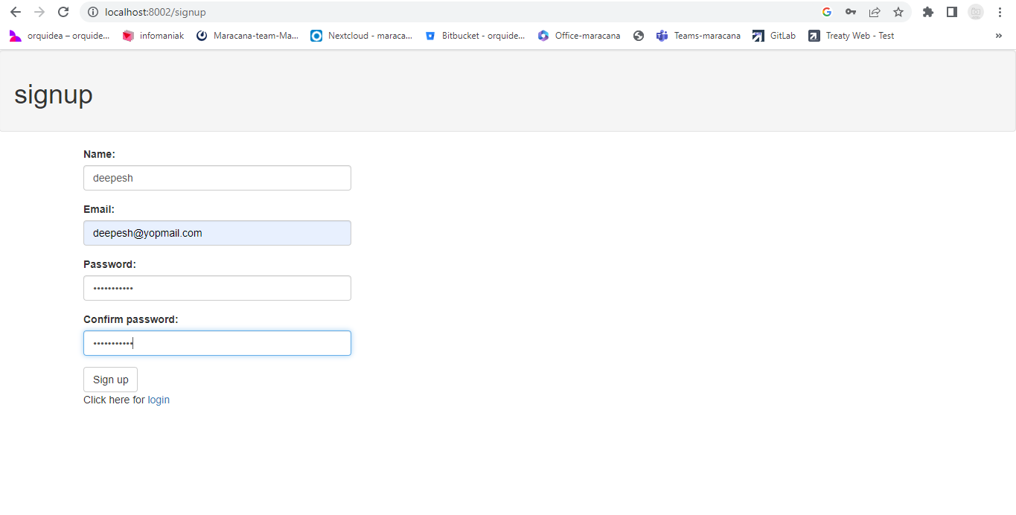

**User Dashboard : Here login user will create attributes, Products, listing and deletion product**

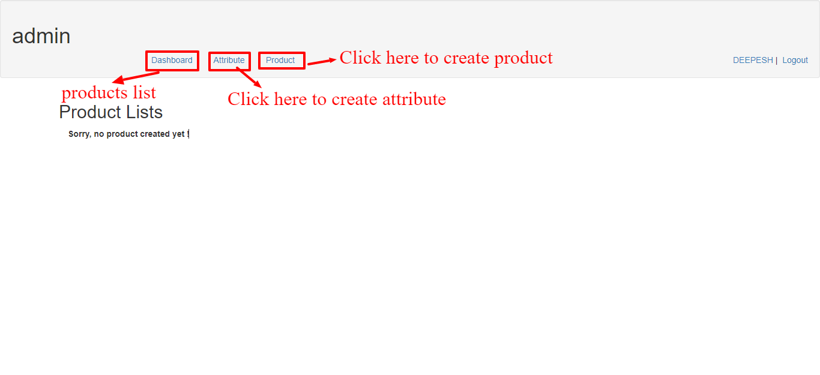

**Attribute Creation using API:**

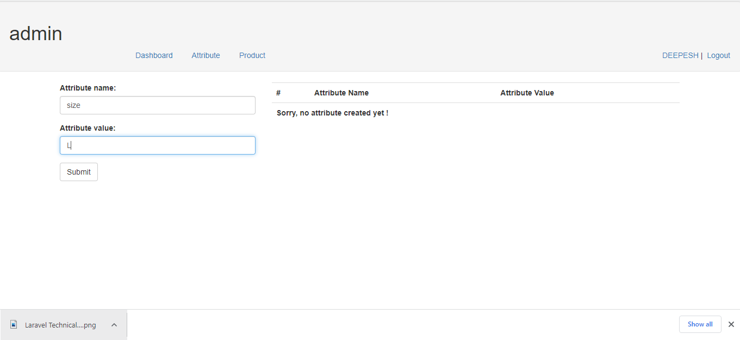

**Attribute Creation and Listing using APIs:**

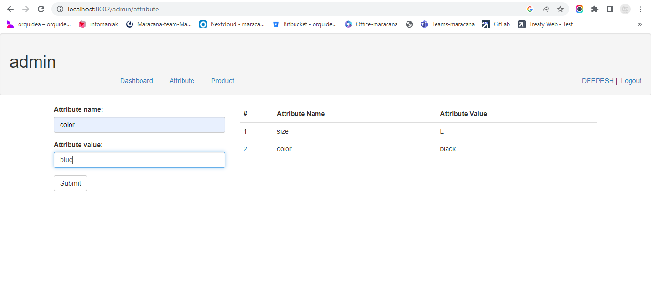

**Product creation with selected attribute id:-**

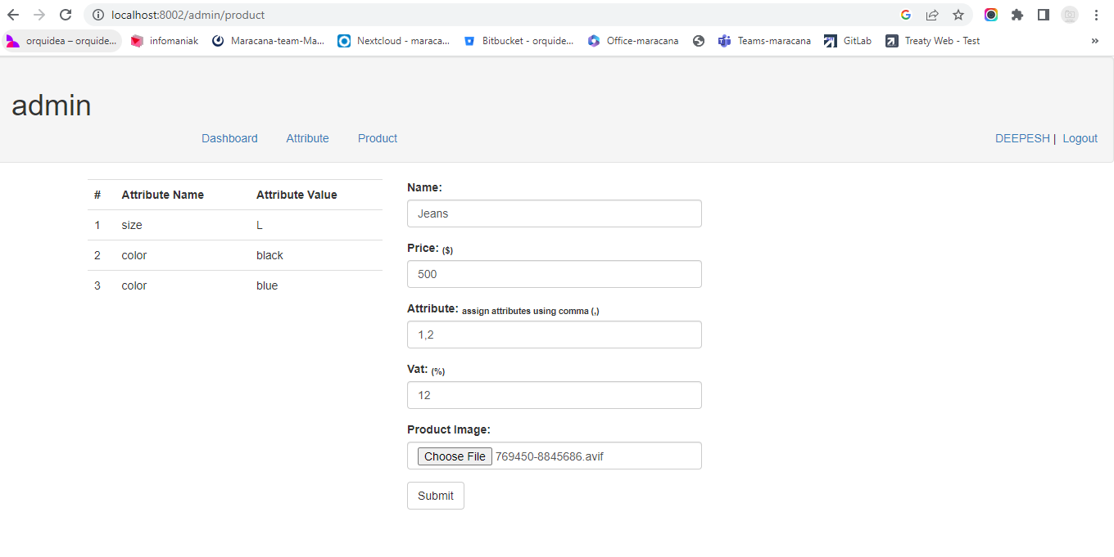

**Product details after product creation:-**

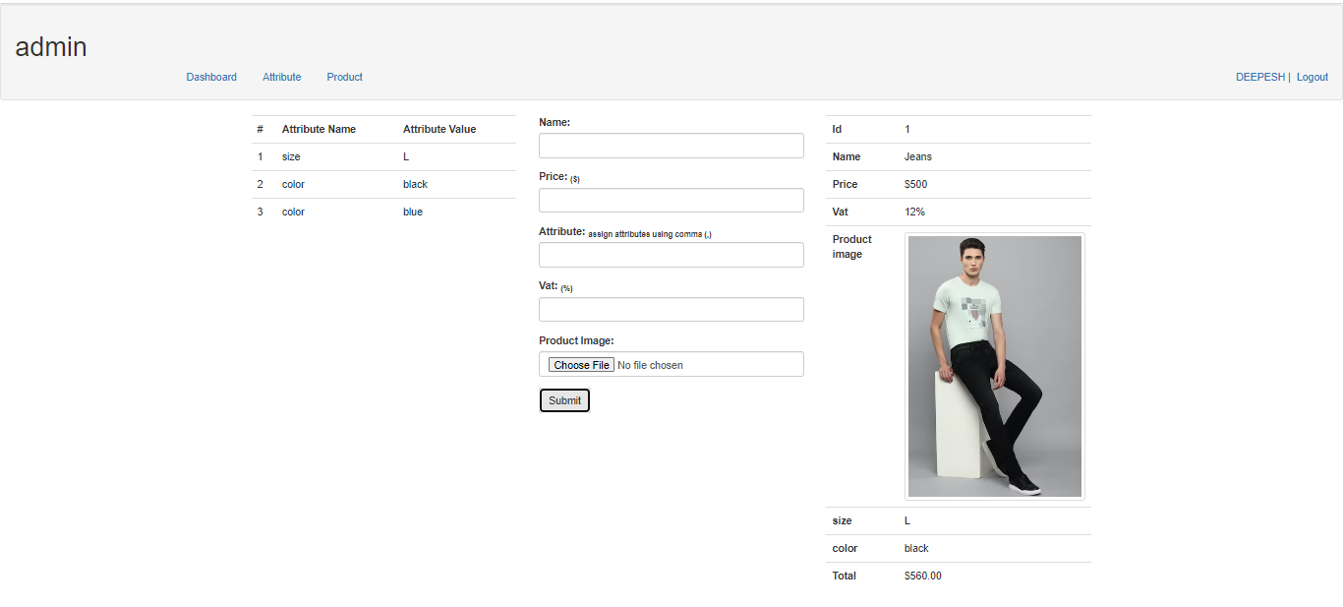

**Products list using APIs:-**

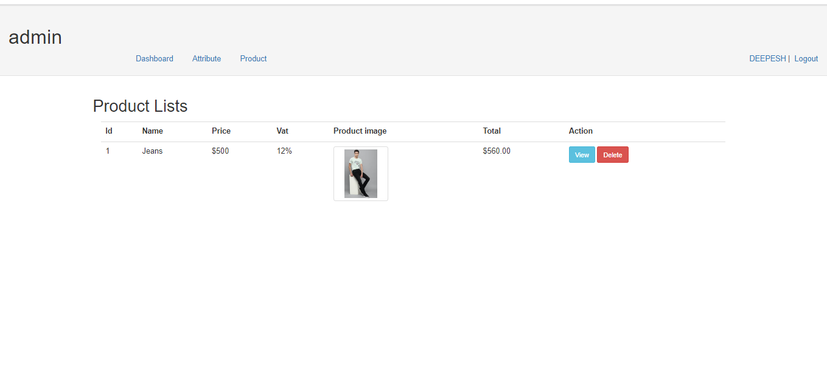

**Products details using APIs:-**

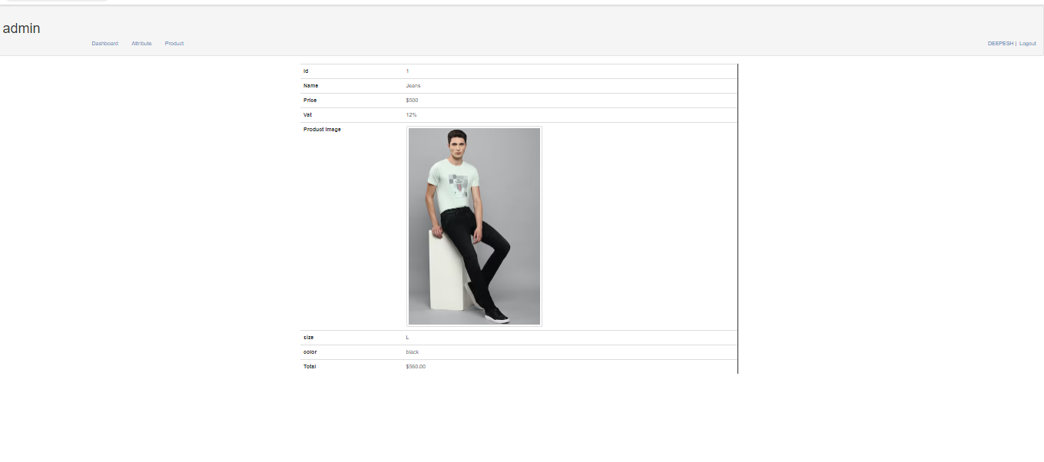

**Products list using APIs with view and delete option:-**

